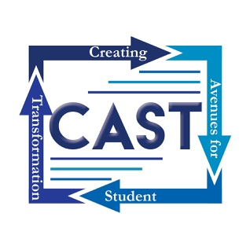
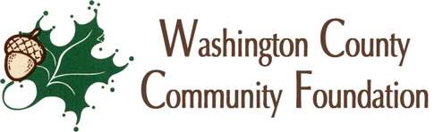

PRESS RELEASE
Cassie Corp: CAST Executive Director
1645 S State Rd 135
Salem, IN 47167
812-620-7907
March 19, 2018
FOR IMMEDIATE RELEASE

CAST Plans Dyslexia Intervention in Washington County, Indiana:
Did you know that dyslexia affects roughly 20% of the general population? This neurological learning disability can mean difficulty with word recognition, poor spelling, reduced reading comprehension, and often children with dyslexia are reading below grade level and unable to get the support they need to be successful readers. But there is good news: 95% of reading failure can be prevented by intervening during early school years, using the correct reading system, and well-trained teachers. The particular method of systematic multisensory phonetics is incredibly effective when implemented early in an academic career. In the spirit of this hopeful statistic, Creating Avenues for Student Transformation, (CAST) is working to implement a community-wide Dyslexia Intervention Plan to ensure that dyslexic students have the academic support they need to excel.
This intervention has three major phases. Phase 1 includes a 2-week training that will be offered through the Dyslexia Institute of Indiana. This extensive 50-Hour Orton Gillingham Reading Specialist training will be offered to selected educators in all 3 county schools so they can begin implementing these reading strategies in classrooms.
In the 2019-2020 school year, all Indiana students in Kindergarten -2nd grade will be screened for dyslexia. Because of this new legislation, many new diagnoses are likely. As teachers are trained in this teaching method, it will begin making a huge difference in student success, but many students will need additional support in addition to classroom instruction. Phase 2 will seek out volunteer tutors. These tutors will also need to attend the 2 week Orton Gillingham training and will then be matched with dyslexic students as they are identified through screening and diagnosis. Tutoring sites for Salem and West Washington school districts will be at Southern Hills Church and Mt. Tabor Christian Church respectively. A tutoring site for the East Washington school district is still to be confirmed.
This project is the brain child of Erin and Dustin Houchin, who are passionate about this issue. They have personal experience with the effectiveness of this intervention. They were able to get their son the help he needed but they quickly learned that other children in our community are not afforded the same opportunity: “After coming to terms with the fact that there is no infrastructure here, we decided to try to build a support system. Through the help of our church, Mount Tabor, as well as Southern Hills Church and the CAST program, the Washington County Community Foundation, and corporate and private partners and donors, we are on the verge of launching what we hope will become a Southern Indiana Dyslexia Institute that can provide help in detecting, accommodating, treating and tutoring children with dyslexia, as well as providing dyslexia training for teachers in our school systems and serving as a resource for parents of newly diagnosed children.” This Southern Indiana Dyslexia Institute is phase 3 of the Dyslexia Intervention Plan. The hope is that Washington County can grow to be a hub of services in a severely under-served region.
CAST is currently working along with Southern Hills Church, Mount Tabor Christian Church and various other organizations to bring all 3 phases of this ambitious plan to fruition. This teacher and tutor training would not be possible without the substantial investment of the Washington County Community Foundation. Judy Johnson, Foundation Executive Director, is enthusiastic about this partnership, “This is a great follow-up to the training we offered last summer to our county teachers when we brought in the Ron Clark Academy. Although this event is more targeted, I think this training will have widespread effect in our county. We are happy to partner with CAST on this and we are so grateful to our generous donors who made this possible. Our donors are having a tremendous impact throughout Washington County.” The Touch Tomorrow funds that have made such a huge impact on this dyslexia project will continue to be important to the development of the community: “Our donors to the Touch Tomorrow Funds made this training move from dream to reality. Because of their generosity, we were able to fund this training in a very big way. The Touch Tomorrow funds allow us to be responsive to the ever-changing needs of our community and respond to opportunities like this. Currently, we are offering a matching grant for donations to a Touch Tomorrow Fund. For every dollar a donor gives to this type of fund, we will match that dollar with two dollars. This is a great time to start or build a fund in the Washington County Community Foundation.”
The 50 hour Orton Gillingham training will be held at the Community Learning Center from June 3rd- June 14th with possible additional training dates added in the near future. Applications may be found at Southern Hills Church or Mount Tabor Christian Church. Space is extremely limited and applications must be turned in to CAST by May 1st to be considered. Individuals who attend the training must commit to at least 1 year of tutoring or be teachers in Washington County, Indiana. Funds are still being collected to fully fund this and future trainings. All who are interested in donating may direct payment to CAST at 1645 S State Rd 135 in Salem IN. Checks should include “Dyslexia Intervention” in the memo line. For more information contact Cassie Summers-Corp at 812-620-7907 or csummers@rc.edu.

